

Lab 1- bit.ly/3SsNbj4

|  |  |
| --- | --- |
| Name | Hannah Rodtmann |
| Date | January 23rd 2025 (23/1/25) |
| Student No | S00266759 |
| Student Email | S00266759@atu.ie |

### **GitHub**

1. Make a copy of this document on Google Docs
2. Go to <http://github.com>
3. Sign up for a GitHub Account (make sure to use your ATU Sligo student email address when you signup as this will entitle you to a free Student that includes 5 free private repositories.)
4. Enter your GitHub username here and also enter it into this [form](https://forms.gle/2WXr81guCMnnAb989):

|  |
| --- |
| Hannah-R2479 |

1. Once your account has been setup, try creating a new Repository called **firstrepo** using the Add Repository button below your profile picture.
2. Use the Add File button to add a new file to your repository, give your new file a name, type some text and save the file.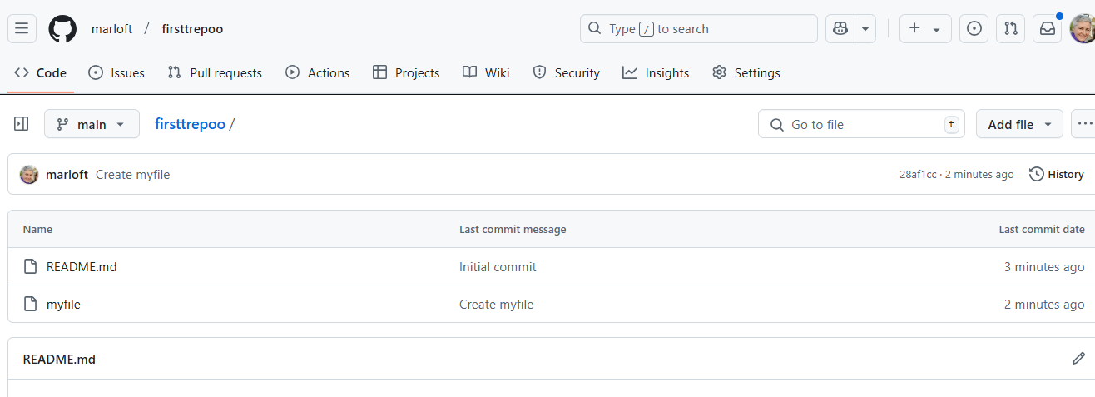

### **Arduino IDE & Coding Basics**

1. Find the Blink tutorial on the Arduino Website

<https://www.arduino.cc/en/Tutorial/BuiltInExamples/Blink>

1. Open the Blink Sketch in the Wokwi emulator here: <https://bit.ly/3S8HxS6>:   
     
   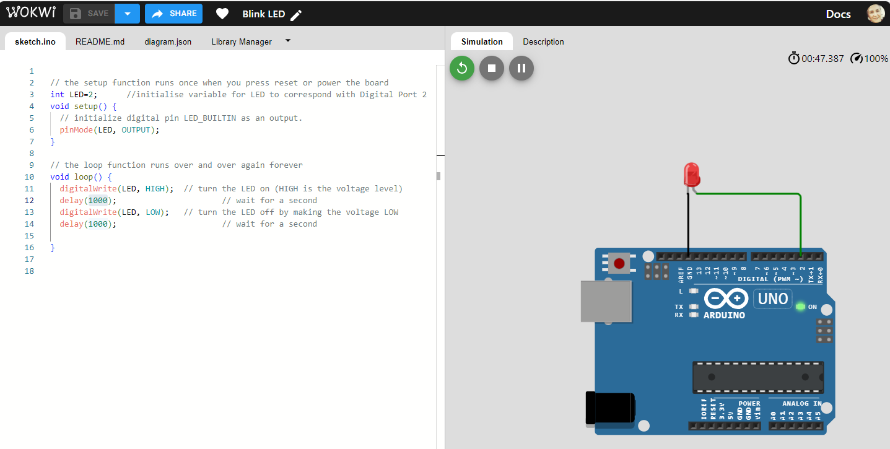
2. Change the blink delay values to 500 - what will be the effect of this change?

|  |
| --- |
| The delay would be changed from 1000 milliseconds or 1 second to 500 milliseconds or half a second, each interval being quicker as the LED would flicker at a quicker rate. |

1. Add a ‘modified by’ line to the sketch comment at the top, with your name and date and paste a screen shot replacing this one:  
   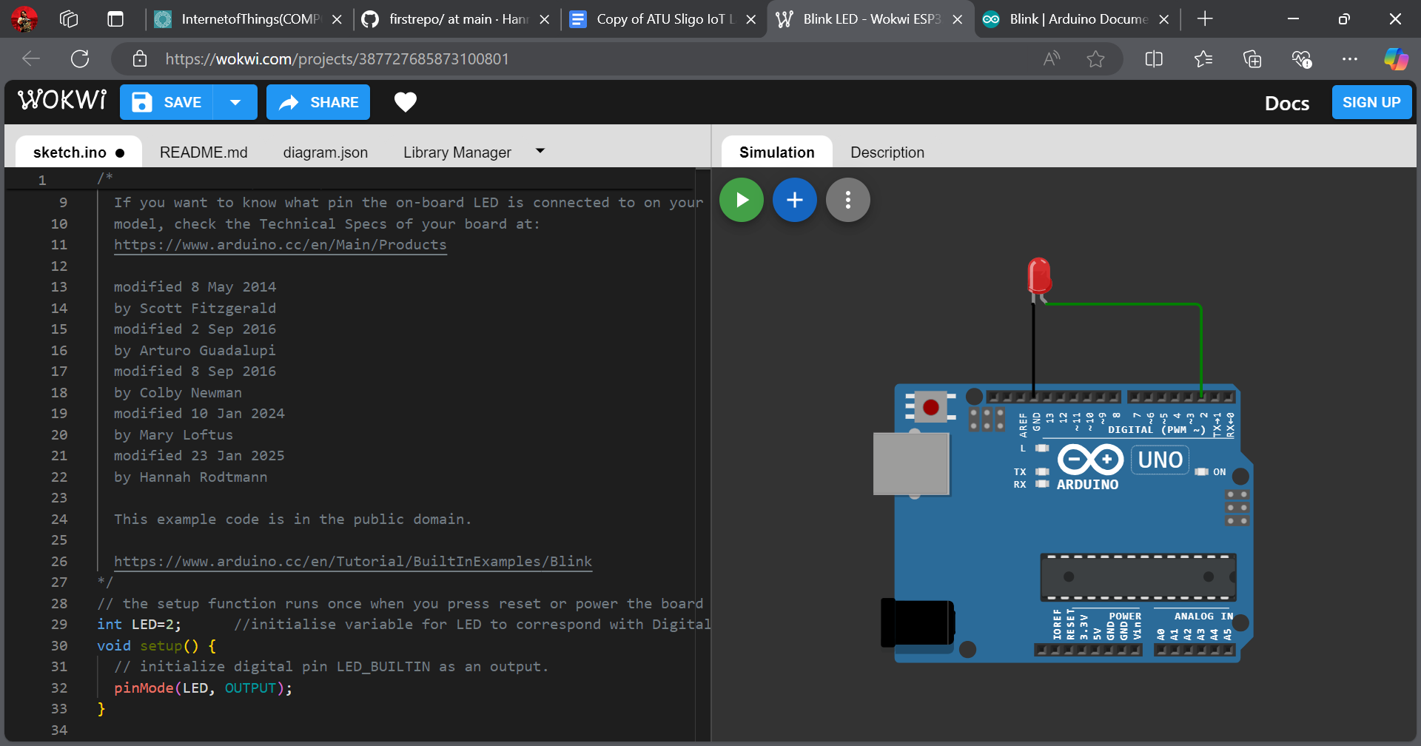
2. Upload your version of Blink to your GitHub account and provide the link here:

|  |
| --- |
| e.g. <https://github.com/Hannah-R2479/firstrepo/blob/main/Updated%20Blink%20LED> |

1. Paste a screenshot here of your code uploaded to GitHub  
   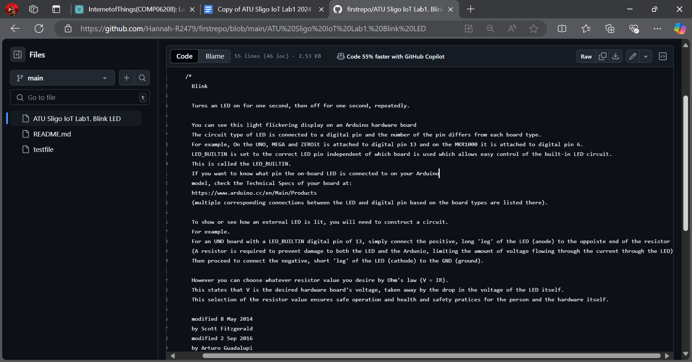
2. ***Upload your Lab to Moodle!***